**Objective**: Learning about some Oracle functions and learn how to use them.

**Aggregate functions:**

**Round(n,m):** Returns n, rounded to m places to the right of a decimal point. m must be integer. If m is omitted n is rounded to 0.

**Syntax:** ROUND(n,m);

Ex: SELECT ROUND(14.015, 2) "Round" FROM DUAL;

**Output:**

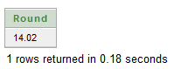

**SQRT:** It returns a square root of n. If n<0,NULL. SQRT returns a real result.

**Syntax:** SQRT(n);

**Ex:** SELECT SQRT(16) "Square root of 16" FROM DUAL;

**Output:**

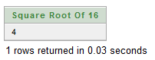

**EXP:** Returns e to the nth power, where e=2.71828183.

**Syntax:** EXP(n);

**Ex:** SELECT EXP(2) "exponetial of 2" FROM DUAL;

**Output:**

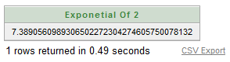

**String aggregate functions:**

**LOWER:** Return char with all letters in lower case.

**Syntax:** LOWER(char);

**Ex:** SELECT LOWER('ICT') "lower form" FROM DUAL;

**Output:**

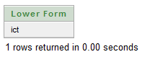

**INITCAP:** Return a string with the first letter of each word in upper case.

**Syntax:** INITCAP(char);

**EX:** SELECT INITCAP('mamunur rashid') "initcap" FROM DUAL;

**Output:**

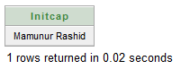

**UPPER:** Return char with all letters uppercase.

**Syntax:** UPPER(char);

**Ex:** SELECT UPPER('mamunur rashid') "upper" FROM DUAL;

**Output:**

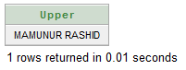

**SUBSTR:** Returns a portion of characters, beginning at character m and going up to character n. if n is omitted the result returned is up to last position. First position of string is 1.

**Syntax:** SUBSTR(<string>, <start_position>, <length>);

**Ex:** SELECT SUBSTR('Mamunur Rashid',1,5) "substring" FROM DUAL;

**Output:**

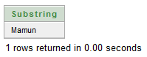

**LENGTH:** Returns length of a word.

**Syntax:** LENGTH(word);

**Ex:** SELECT LENGTH('Mamunur Rashid') "Length" FROM DUAL;

Output:

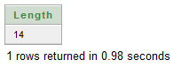

**LTRIM:** Removes character from char with initial characters removed up to the first character not in set.

**Syntax:** LTRIM(char, set);

**EX:** SELECT LTRIM('Mamunur Rashid','Mamun') "left trim" FROM DUAL;

**Output:**

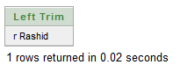

**RTRIM:** Returns char, with final characters removed after the last character not in the set.

**Syntax:** RTRIM(char,set);

**Ex:** SELECT RTRIM('Mamunur Rashid',' Rashid') "left trim" FROM DUAL;

**Output:**

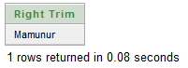

**LPAD:** Return char1, left padded to length n whit the sequence of characters specified in char2.

**Syntax:** LPAD(char1, n, char2);

**Ex:** SELECT LPAD('Mamunur Rashid', 20, '*') "left trim" FROM DUAL;

**Output:**

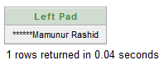

**RPAD:** Return char1, right padded to length n whit the sequence of characters specified in char2.

**Syntax:** RPAD(char1, n, char2);

**Ex:** SELECT RPAD('Mamunur Rashid', 20, '*') "left trim" FROM DUAL;

**Output:**

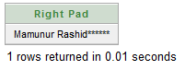

**Date functions:**

**TO_DATE:** Converts a character field to a date field.

**Syntax:** TO_DATE(char, format);

**Ex:** SELECT TO_DATE(SYSDATE,'DD-MM-YY') "date" FROM DUAL;

**Output:**

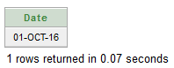

**ADD_MONTHS:** Returns the date after adding the months specified.

**Syntax:** ADD_MONTHS(date, number_of_month);

**Ex:** SELECT ADD_MONTHS(SYSDATE,2) "add months" FROM DUAL;

**Output:**

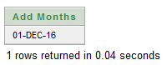

**LAST_DAY:** Returns the last date of the month specified with the function.

**Syntax:** LAST_DAY(date);

**Ex:** SELECT LAST_DAY(SYSDATE) "last day" FROM DUAL;

**Output:**

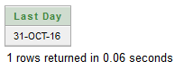

**MONTHS_BETWEEN:** Returns the months between d1 and d2.

**Syntax:** MONTHS_BETWEEN(date1, date2);

**Ex:** SELECT MONTHS_BETWEEN('07-JAN-2001','07-NOV-1993') "months between" FROM DUAL;

**Output:**

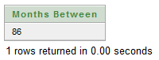

**NEXT_DAY:** Returns the date of the first weekday named by char that is after the date named by date.

**Syntax:** NEXT_DAY(date, char);

**Ex:** SELECT NEXT_DAY('07-NOV-1993','Friday') "next day" FROM DUAL; **Output:**

